Supplementary Information for
A Diameter-Adaptive, Suture-Free Conduit with Magnetoelectric Responsiveness Promotes Peripheral Nerve Regeneration

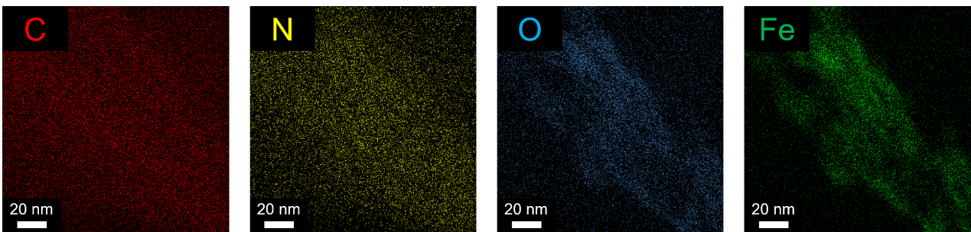
Fig. S1. EDS mapping images of PFeC nanohybrid. The Fe, N, and O signals were primarily localized along the CNT backbone, confirming the PDA-mediated deposition of Fe₃O₄ nanoparticles on the CNT surface.

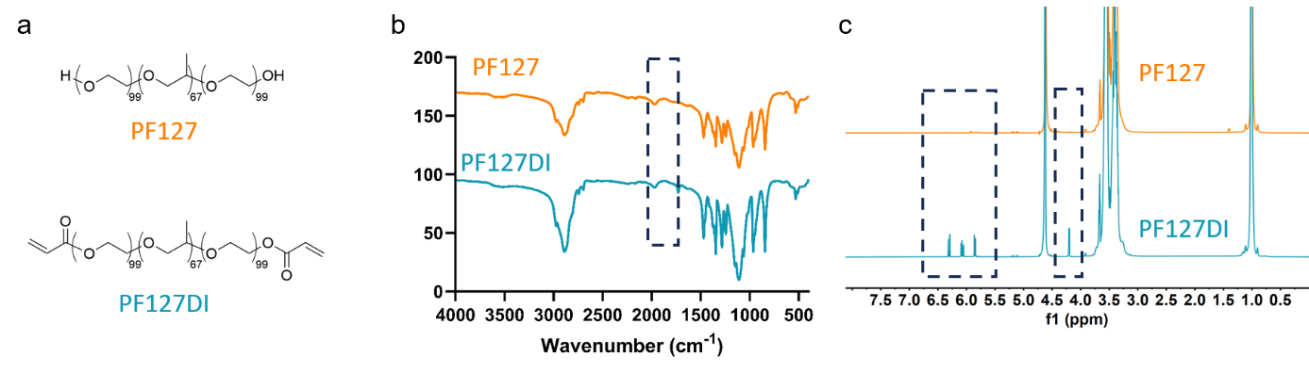
Fig. S2. Characterization of PF127 and PF127DI. (a) Chemical structures of PF127 and PF127DI. (b) FTIR spectra of PF127 and PF127DI. (c) ¹H NMR spectra of PF127 and PF127DI.

Fig. S3. Compressive stress–strain analysis of hydrogels. Compared to P/A and P/A/PFeC hydrogels, the P hydrogel is too soft and unsuitable for stress-strain curve testing.

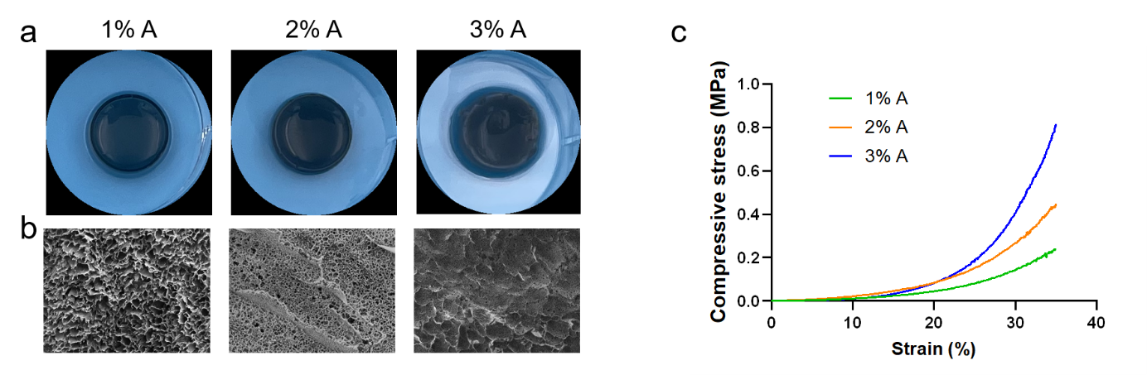
Fig. S4. P/A/PFeC hydrogels with different concentrations of A. (a) Macroscopic photos of 1%, 2% and 3% P/A/PFeC hydrogel. (b) SEM images of 1%, 2% and 3% P/A/PFeC hydrogel. (c) Compressive stress–strain curves of 1%, 2% and 3% P/A/PFeC hydrogel.

Fig. S5. Shrinkage ratio of P/A and P/A/PFeC conduit. Data: mean ± SD (n = 6). *P < 0.05, **P < 0.01, ***P < 0.001, ****P < 0.0001; ns: not significant.

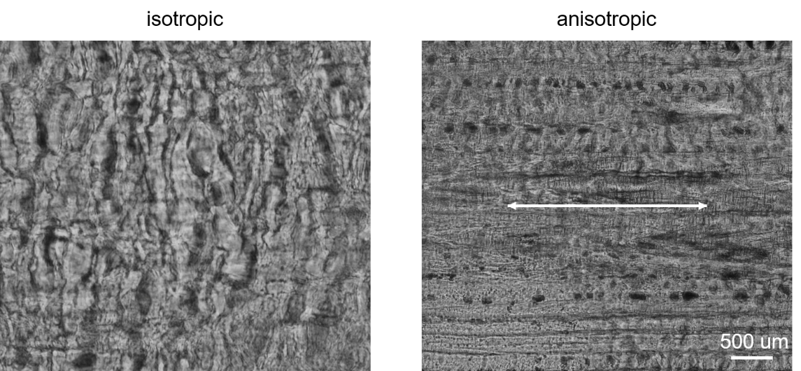
Fig. S6. Polarized optical microscopy images of isotropic and anisotropic P/A/PFeC hydrogels. The anisotropic hydrogel exhibits a distinct aligned internal structure (indicated by the white arrow), whereas the isotropic group shows a random and disordered morphology.

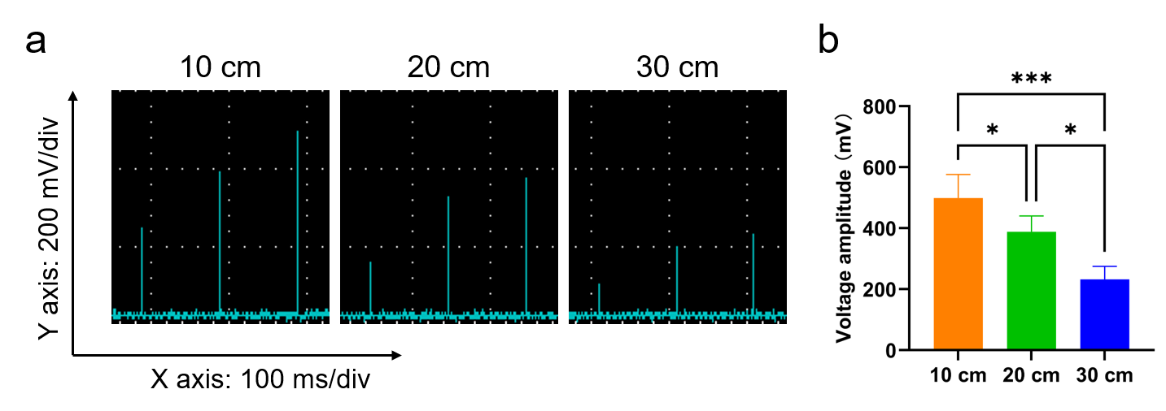
Fig. S7. Distance-dependent induced voltage output of anisotropic P/A/PFeC hydrogel under alternating magnetic field stimulation. (a) Representative oscilloscope waveforms of voltage amplitude at different coil-to-sample distances (10, 20, and 30 cm). (b) Quantitative analysis of voltage amplitude. Data: mean ± SD (n = 3). *P < 0.05, **P < 0.01, ***P < 0.001, ****P < 0.0001; ns: not significant.

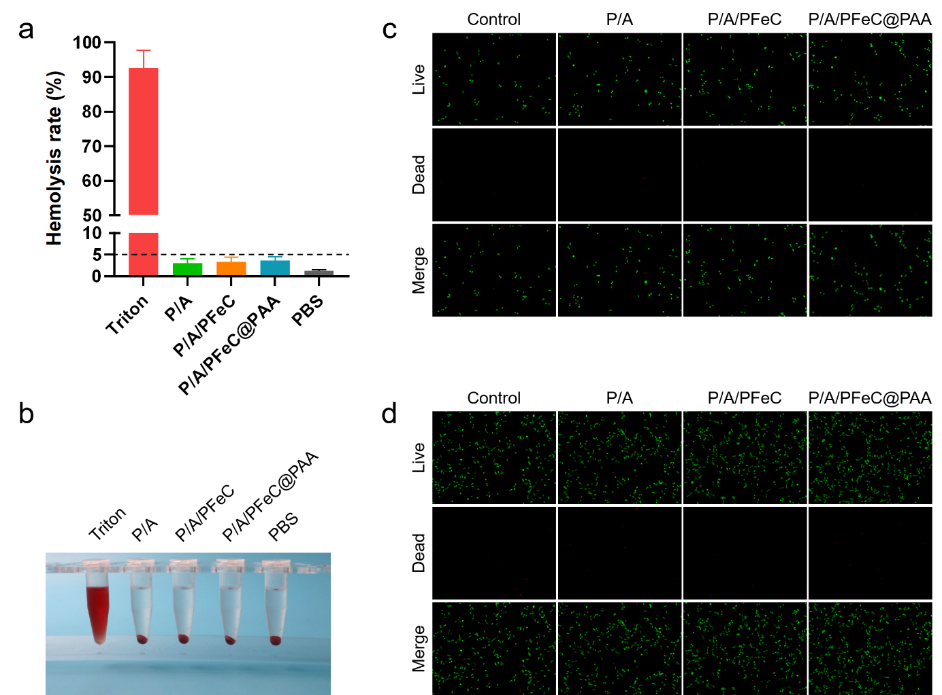
Fig. S8. Hemocompatibility and cytocompatibility of different hydrogel groups. (a-b) Hemolysis tests of of different hydrogel groups, with Triton X-100 as the positive control and PBS as the negative control. (c-d) Live/dead staining of Schwann cells cultured on the hydrogels for 1 and 3 days.

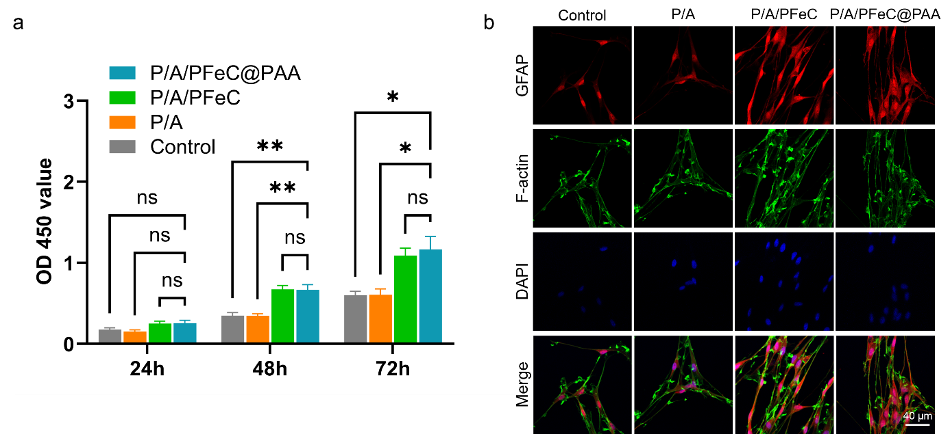
Fig. S9. Schwann cells cultured on different hydrogel groups under alternating magnetic field stimulation. (a) CCK-8 assay quantifying Schwann cell proliferation at 24, 48, and 72 h. (b) Representative fluorescence images of Schwann cells stained with GFAP. Data: mean ± SD (n = 3). *P < 0.05, **P < 0.01, ***P < 0.001, ****P < 0.0001; ns: not significant.

Fig. S10. ELISA analysis of cytokine secretion by macrophages cultured on different hydrogel groups under alternating magnetic field stimulation. Data: mean ± SD (n = 3). *P < 0.05, **P < 0.01, ***P < 0.001, ****P < 0.0001; ns: not significant.

Fig. S11. Temperature monitoring during IR irradiation of the conduit. Representative photographs showing the local temperature recorded on the inner surface of the conduit during infrared exposure. The measured temperature increased from approximately 20.5 °C before irradiation to 30.8 °C at 20 s and 34.3 °C at 35 s, indicating a relatively mild thermal exposure during the IR-triggered contraction process.

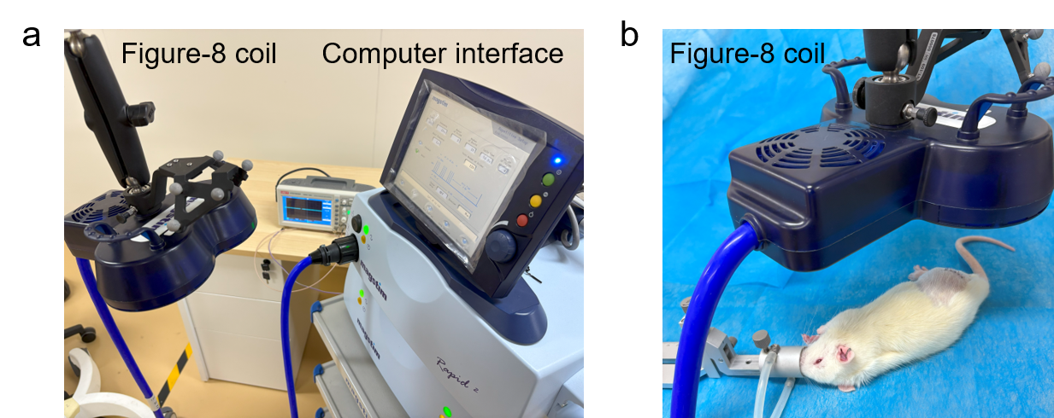
Fig. S12. The magnetic stimulator and post-surgery stimulating process. (a) The general view of the entire equipment with the computer interface for setting up the parameters and the figure-eight coil for generating alternating magnetic field. (b) The exposure of post-surgery rats to the alternating magnetic field.

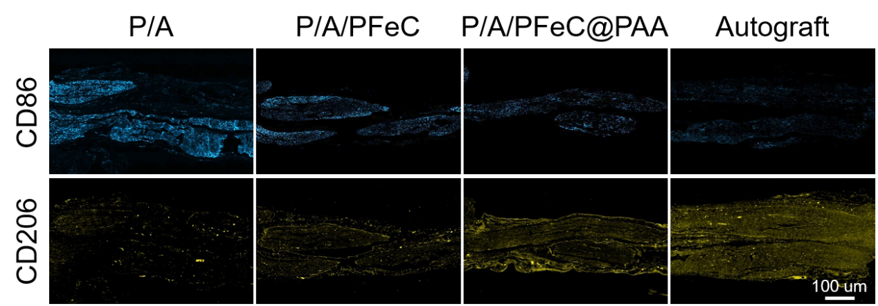
Fig. S13. Immunofluorescence staining of macrophage polarization markers. Representative images of CD86 (M1 marker) and CD206 (M2 marker) expression at the injury site 2 weeks post-implantation. Compared to the P/A and P/A/PFeC groups, the P/A/PFeC@PAA group exhibited lower CD86 and highest CD206 expression, indicating a more pronounced shift toward M2 macrophage polarization. This enhanced anti-inflammatory response can be attributed to the synergistic effects of suture-free adhesion and magnetoelectric stimulation.

Fig. S14. In vivo degradation rates of P/A, P/A/PFeC, and P/A/PFeC@PAA conduits at 4, 12, and 24 weeks. Data: mean ± SD (n = 3). *P < 0.05, **P < 0.01, ***P < 0.001, ****P < 0.0001; ns: not significant.

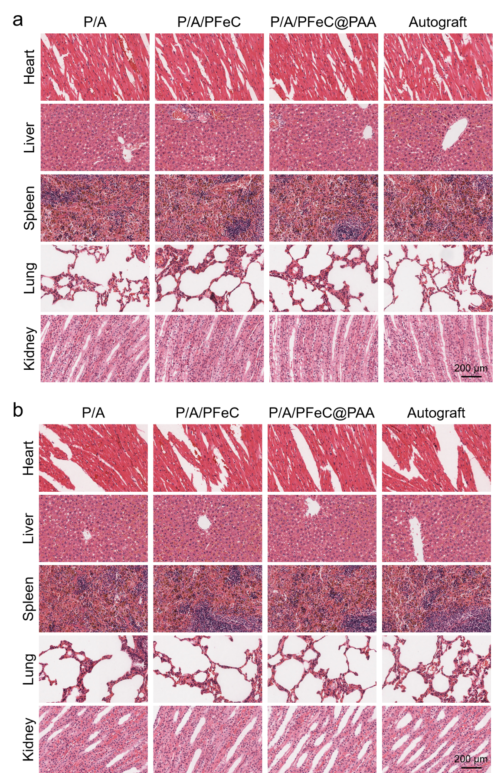
Fig. S15. Histological analysis of major organs. (a) Representative HE staining images of heart, liver, spleen, lung, and kidney tissues at 12 weeks after implantation. (b) Representative HE staining images of heart, liver, spleen, lung, and kidney tissues at 24 weeks after implantation.

